RAZIYA BANU
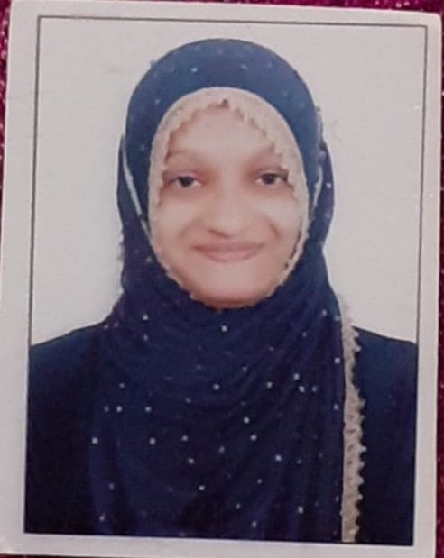
Phone no : 9739118485
Email ID : raziyabanu1710@gmail.com
OBJECTIVE : Seeking a challenging position in a reputed organization where I can learn new skills , expand my knowledge and leverage my learnings.
SOFT SKILLS :
- Empathy
- Leadership
- Positivity
- Self -motivation
HARD SKILLS :
- Design
- Writing skills
- Mathematics
EDUCATION :
- PRE UNIVERSITY COURSE
Corporation Girls Pu College, Cleveland Town, Bangalore 560005, in 2021-2022.
GRADE : First Class (82%)
- SECONDARY SCHOOL LEAVING CERTIFICATE
Government High School, Pottery Town. Civil Station, Bangalore North, in 2019-2020.
GRADE : Distinction (87%).
EXPERIENCE : 1 year
As a Telesales Executive in Prime Placement Vision Pvt Ltd

INTEREST :
- Art
- Music
- Cooking
- Writing
- Learning Language's
LANGUAGE'S :
- Urdu ( Mother language)
- Kannada ( Fluent)
- English ( Communicative)
- Hindi ( Intermediate)
PERSONAL DETAILS :
- Date of birth : 17/10/2003
- Marital status : Single
- Father name : Mohammed Umar
- Nationality : Indain
- Address : Devarajeevana halli, tannery road , Bangalore North , Bengaluru 560045

